

PROG POE PART 1

ST10091991



April 18, 2024

VC Waterfall

**Table of Contents**

Pg 1 - Introduction & Background  
Pg 2 - Vision and Objectives  
Pg 4 - Understanding non-functional and functional needs  
Pg 7 - Role of the design and architecture patterns.

Pg 8 - High level plan

Pg 10 - Conclusion  
Pg 12 - Reference list

**Introduction & Background**

According to Sihlobo from The Conversation South African farmers face multiple issues that affect the agriculture industry that are applicable in South Africa such as:  
  
1. Energy cuts / Power cuts  
2. Land reformation  
3. Lack of progress on key regulations  
4. The financing of the sector

(Sihlobo, 2024)  
  
With these real-world issues stated and present in South Africa the agriculture industry demands a solution thus is where IT steps in (Sheldon, 2023). The production of a multi-functional agricultural records and processing system that is capable of sharing information amongst farmers, green energy experts, and enthusiasts to tackle the current issue found in South Africa, this solution is called the Agri-Energy Connect Platform. This is a multi-functional platform that uses the MVC (Model view control) architectural pattern which is easily scalable to any laptop-based operating system and with the optionality of an android and IOS operating system capability which allows the application to be scalable to mobile cellular devices (Sheldon, 2023).

**Vision and Objectives**

The vision of the Agri-Energy Connect Platform is to create a digital ecosystem that allows a group or community within the Agriculture and environment industry to share resources and data with regards to the land conditions and additional data that helps collaborate, innovate and sustain in the agriculture and renewable energy sectors in Sout Africa (Sharma, 2023).  
  
The given challenge will not have a simple solution however requires complex system integration and multi-functional application layers as well as security and scalability that allows multi access to many forms of devices (Sharma, 2023). The complexity of this system has been broken down into smaller sections to ensure better handle-meant of the development of this application by making critical objectives which aim to target critical success criteria which are used to build the application piece by piece until it is fully complete (Sharma, 2023). These Objectives are as followed:  
  
1. Facilitating knowledge exchange and resources between farmers, green energy experts and enthusiasts via multiple data storing options such as databases, files and dashboards that allows a user to comment on a topic or item (Sheldon, 2023).  
  
2. Teaching and learning sustainable agricultural practices as well as adopting green energy solutions to ensure health and global safety practices (Sheldon, 2023).

3. Ensure the system has special access to educators and trainers as well as having special access to training resources that help educate all necessary individuals. The system will also have special access points based of the specific user’s role that is assigned to the profile account which allows each user to be able to view exclusive features and shared features (Sheldon, 2023).

4. Projects will be connected to funding assets which allow a specific project to be viewed by potential investors which can decide to donate to the project to ensure that the projects have feasible funds at its disposal to ensure it gets implemented (Sheldon, 2023).

**Understanding the non-functional and functional needs**

**Non-functional needs:**  
1. **Security** - The platform needs to guarantee customer data and transactions are available, secure, and secret. To reduce security threats, steps like access restriction, encryption, and frequent security audits are crucial. Multiple applicable solutions such as hash password, user verification questions and additional features that allow security, encryption, and protection for the system.  
2. **Scalability** - Over time, the platform needs to be able to handle an expanding user population as well as rising content and transaction volumes. A few scalability factors are load balancing, database query optimization, and horizontal scaling. The application design will allow the system to be cross platform and compactible.  
3. **Usability** - The platform ought to be user-friendly and intuitive, accommodating users with different degrees of technical proficiency. Enhancing usability and user experience should be the goal of interactive components, navigation frameworks, and user interface design. With this functional need it is important to keep the system simple and not complex.  
4. **Performance** - Even with high loads, the platform should have quick reaction times and excellent responsiveness. To increase system performance, performance optimization strategies including database indexing, code profiling, and caching may be used. The application will be using a hybrid architecture pattern that will allow data to be pulled from the database and locally added to the machine to allow local debugging. The database will be a relational SQL database due to its high performance linking.  
5. **Reliability** - The platform must be stable and dependable, with little downtime and interruptions in service. To guarantee service continuity, disaster recovery plans, redundancy, and fault tolerance techniques must be in place. This is easily achievable as if the database is offline the system goes into an offline mode which allows the user to still be able to use the software but with limited functionality.  
6. **Accessibility** - Users with disabilities should be able to access the platform, and it should adhere to all applicable accessibility standards and guidelines. This could entail supporting keyboard navigation, offering alternative text for images, and being screen reader compatible.  
7. **Compliance** - The platform must abide by all applicable laws and regulations regarding consumer rights, privacy, and data protection. GDPR compliance, PCI-DSS compliance (for payment processing), and conformity to industry standards are a few examples of compliance measures.  
  
**Functional needs:**1. **User authentication** - It should be safe for users to create accounts, log in, and manage them. Different user roles may have different access levels to features and material, such as farmers, specialists in green energy, and fans. Via the system the specific user account will be assigned a designated role that will allow the user to view and have access to role specific content and features.  
2. **Content Management** -Administrators should be able to add, modify, and oversee a variety of content kinds on the platform, including project listings, articles, forums, and resources. Additionally, users ought to be able to submit content, but this could need to be moderated. Content will be able to be viewed, added, edited, or removed based of the role designated system.  
3. **Communication and collaboration** - It should be possible for users to communicate with one another via forums, comments, and messaging. Project workspaces and document sharing are examples of collaboration technologies that should promote knowledge sharing and teamwork. The specific features associated will allow all users to be able to interact with one another, follow projects and other additional aspects as this will be an open ground with no role restrictions.  
4. **Marketplace Functionality** - The platform ought to facilitate all aspects of the green energy marketplace's transactions, such as order administration, payment processing, and product listings. It should be safe for customers to peruse merchandise, evaluate costs, and complete transactions. This function specifically targets the marketing functionality which allows users to donate or follow the project via the in-built marketplace.  
5. **Educational Resources** - A wide variety of instructional resources, such as articles, webinars, videos, and courses, ought to be available to users. Features for classifying and arranging resources as well as monitoring user progress and interaction should be available on the platform. This functionality will be open to all roles however higher up roles will have special functions associated with them.  
6. **Project Management** - Projects pertaining to sustainable agriculture and renewable energy should be easy for users to create, oversee, and work together on. Task delegation, monitoring of progress, and milestone management are examples of project management capabilities. Designated project managers will be assigned to each project where an assignment system will be put in place.  
 **Role of the design and architecture patterns.**

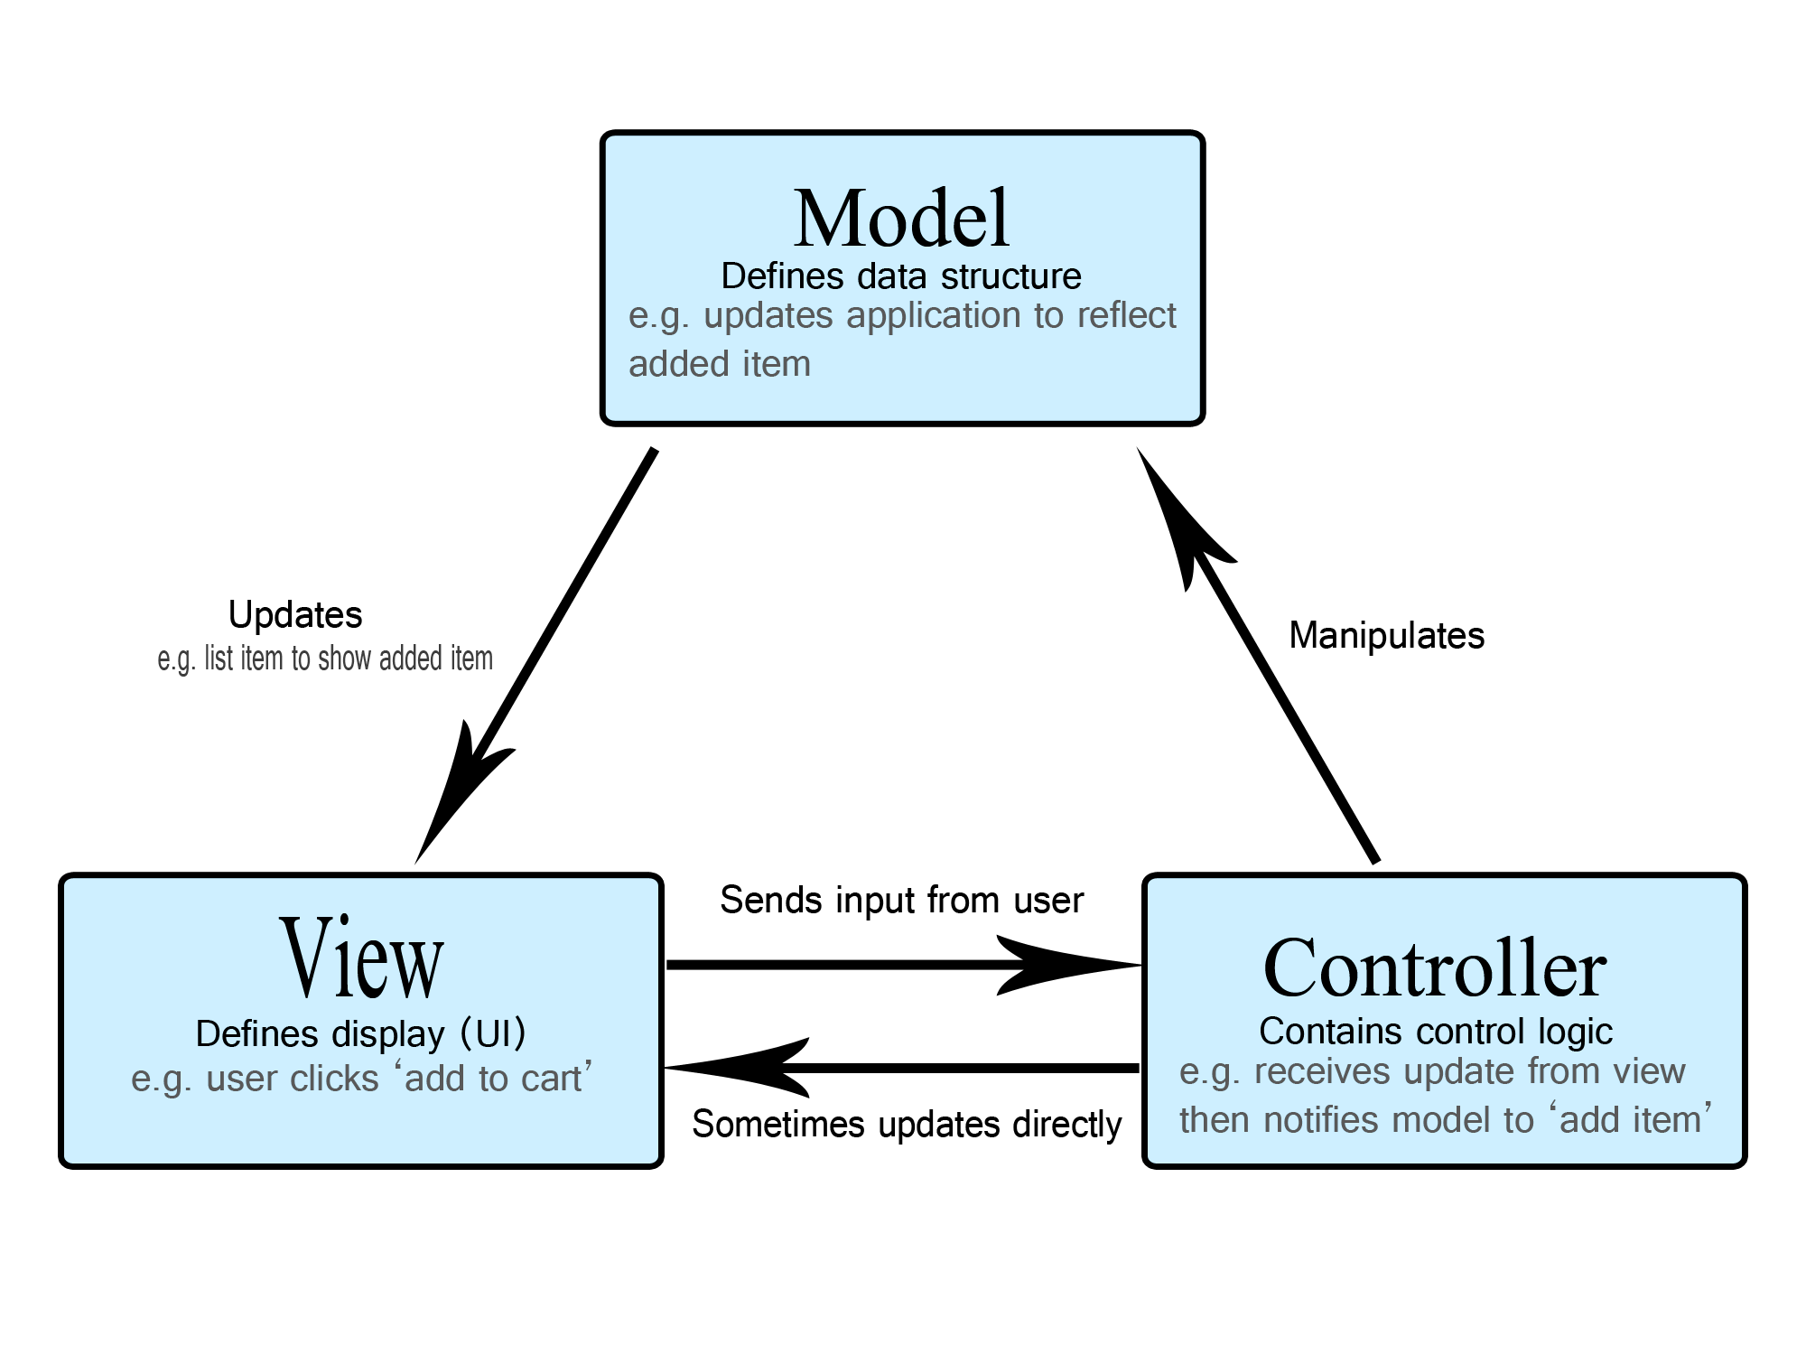

(Horta, 2023)

* **Relevance of Design Patterns:** Because they encourage modularization, reusability, and maintainability in software development, design patterns like MVVM (Model-View-ViewModel) and MVC (Model-View-Controller) are extremely pertinent to the project (Horta, 2023).
* **Integration Strategies:** By organizing our software in accordance with best practices, dividing up our concerns, and utilizing frameworks and libraries that provide out-of-the-box support for these patterns, we will incorporate design patterns into the project (Horta, 2023).
* **Justification**: By encouraging code structure, lowering complexity, and fostering developer collaboration, these design principles improve the platform. We may increase the codebase's readability, maintainability, and extensibility by using accepted patterns (Horta, 2023).

**High level Plan**

The diagram provided above is a general plan that illustrates the individual components and how they are dependant on one another and the flow of data as well, breaking down the diagram it is separated into 3 main modules where the application module (Middle block) is where the users will be interacting from. The system will then branch out into the special features module if the specific user is an administrator or they system allows the specific user to add, remove or edit content / data from the system. The entire application will be using a database to store data and the data will be imported per user from the database to minimize connectivity to the database however certain features won’t be imported as that is an online database handling.

**Conclusion**

Selecting the Model-View-Controller (MVC) architecture for the Agri-Energy Connect platform has certain advantages that correspond well with the needs and goals of the project:   
  
1. **Modularity and Concern Separation**: Model-View-Controller (MVC) encourages the modular construction of applications by separating the presentation (view), data (model), and application logic (controller) into discrete parts. The better code organization, maintainability, and reusability that results from this separation of concerns makes it simpler to manage and grow the program over time (Saafan, 2023).  
  
2. **Scalability**: Because MVC is modular, it allows for the independent scaling of separate components, which promotes scalability (Saafan, 2023). It is possible to add new features to an application without affecting already-existing components as the platform develops, allowing for a smooth expansion to handle a larger user base, more content, and more transactions (Saafan, 2023).

3. **Flexibility and extensibility**: MVC offers an architecture that is both adaptable to future improvements and flexible enough to change as needs do (Saafan, 2023). By adding or changing controllers, models, and views, new functionality can be added without requiring significant alterations to the application's other components or the underlying architecture (Saafan, 2023).   
  
4**. Support for Several User Interfaces**: Model-View-Controller (MVC) enables the creation of several UIs that share the same application logic and data at the core (Saafan, 2023). The Agri-Energy Connect platform benefits greatly from this flexibility since it can accommodate a variety of users (such as farmers and experts in green energy) who access the platform through different devices and interfaces (like web browsers and mobile apps) (Saafan, 2023).

5. **Community Support and Ecosystem**: MVC is a popular architectural pattern that has a thriving ecosystem of tools, libraries, and frameworks in addition to broad community support (Saafan, 2023). Using MVC frameworks, like Python's Django, PHP's Laravel, or Java's Spring MVC, can speed up development, give access to best practices, and make routine chores like data binding, routing, and validation easier (Saafan, 2023).   
  
All things considered, the MVC architecture provides a strong base upon which to build the Agri-Energy Connect platform (Saafan, 2023). This allows developers to build a digital ecosystem that is scalable, maintainable, and extensible, thereby encouraging innovation, sustainability, and teamwork in the agricultural and renewable energy sectors (Saafan, 2023).  
  
**Reference list:**

Horta, J.Y.M. (2023) *The importance of good architecture and Design Patterns for high-performance software*, *LinkedIn*. Available at: https://www.linkedin.com/pulse/importance-good-architecture-design-patterns-software-jos%C3%A9-yadiel#:~:text=Good%20architecture%20and%20design%20patterns%20also%20help%20ensure%20that%20the,and%20design%20patterns%20is%20reliability. (Accessed: 17 April 2024).

Saafan, A. (2023) *What are the benefits of using the model-view-controller (MVC) framework in ASP.NET development?*, *LinkedIn*. Available at: https://www.linkedin.com/pulse/what-benefits-using-model-view-controller-mvc-framework-amr-saafan-rjmdf/ (Accessed: 17 April 2024).

Sharma, N. (2023) *Top challenges of developing cross-platform mobile applications*, *kellton*. Available at: https://www.kellton.com/kellton-tech-blog/top-challenges-of-developing-cross-platform-mobile-apps (Accessed: 16 April 2024).

Sheldon, R. (2023) *What is model-view-controller (MVC)?: Definition from TechTarget*, *WhatIs*. Available at: https://www.techtarget.com/whatis/definition/model-view-controller-MVC#:~:text=In%20programming%2C%20model-view-,a%20specific%20set%20of%20tasks. (Accessed: 15 April 2024).

Sihlobo, W. (2024) *Farming in South Africa: 6 things that need urgent attention in 2023*, *The Conversation*. Available at: https://theconversation.com/farming-in-south-africa-6-things-that-need-urgent-attention-in-2023-197772 (Accessed: 15 April 2024).